Chapter 9 Demos Part 1 – Requirements
Oct 13, 2026 · @Jim Kaufmann

Overview
Six in-class demos, one per Chapter 9 Part 1 lab. Each demo uses the same concept as its lab with a different topic, so students see the pattern without getting the lab's code.
Demo | Matches | Concept shown
Demo1 StateCapitals | Lab1 FlashCards | Class with private fields, constructor, getters; array of objects; search and add
Demo2 LibraryBooks | Lab2 StoreInventory | Getters and setters; search, add, update, delete; staff code
Demo3 MealCard | Lab3 BankLogin | Methods that change an object's state; one signed-in object at a time
Demo4 MovieFinder | Lab4 GameBreak | Search on two fields; form methods that return an index or -1
Demo5 CarRental | Lab5 JobEstimate | Properties with get/set; setters that recalculate a total; a constant
Demo6 PaintEstimate | Lab6 TileEstimate | Read-only properties; constructor calculates values; Display() method
Ground rules for every demo
- C# Windows Forms app, one class file per class plus the form.
- Save in /Demos/CH09/CH09P1/, projects named Demo1, Demo2, … Demo6.
- Code must match the UML diagram: - = private, + = public.
- Input validation is kept to a minimum so the code stays short. Assume the user types valid numbers.

Demo1 StateCapitals (pairs with Lab1)
A Windows Forms app that tells the user the capital of a U.S. state.
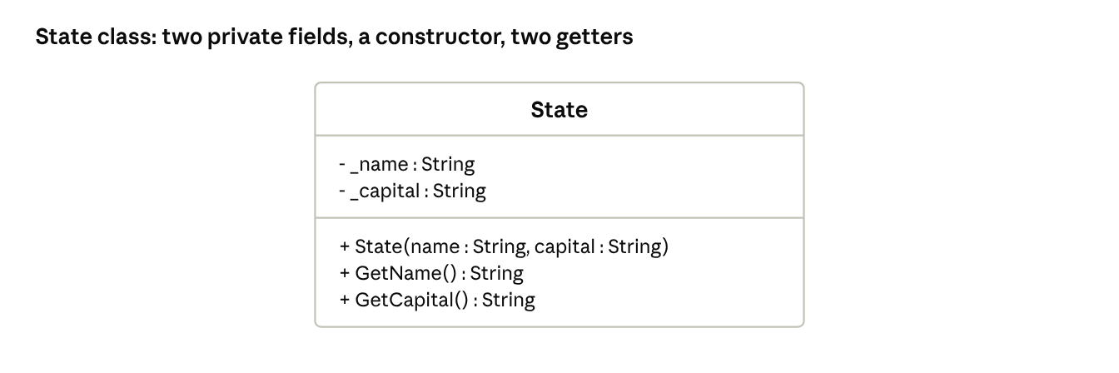
UML · State class
Requirements
- Create a State class that matches the UML above.
- The program stores up to 20 states in an array of State objects.
- The program starts with 5 states: Missouri – Jefferson City, Illinois – Springfield, Kansas – Topeka, Texas – Austin, Ohio – Columbus.
- The user types a state name and clicks Find. The search is case-insensitive.
- If found, display: The capital of Missouri is Jefferson City.
- If not found, display I don't know that state yet. What is its capital? and show a capital text box and an Add button.
- Add creates a new State object and stores it in the array.
- If 20 states are already stored, display The list is full.
Form controls: state text box, Find button, result label, capital text box, Add button (capital box and Add button hidden until needed).

Demo2 LibraryBooks (pairs with Lab2)
A Windows Forms app for a school library to look up and manage books.
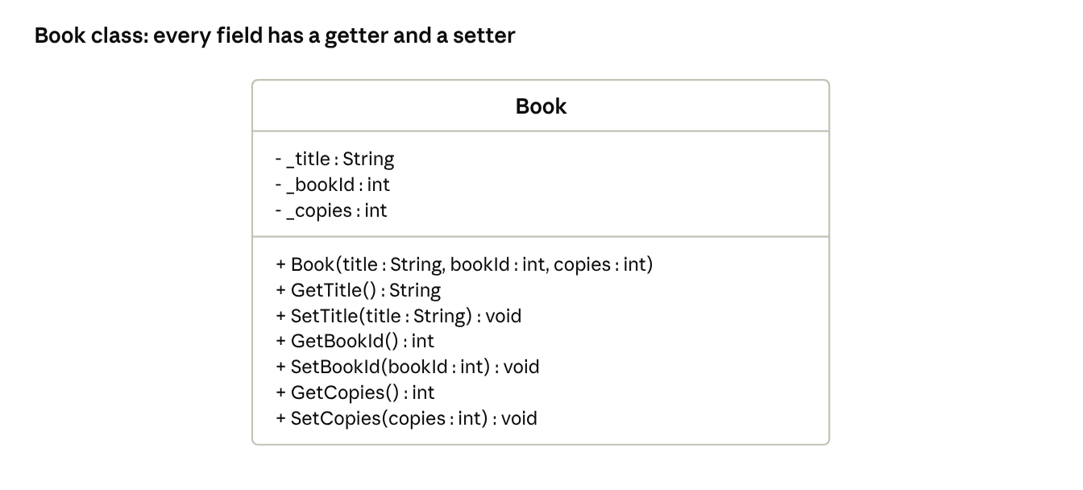
UML · Book class
Requirements
- Create a Book class that matches the UML above.
- The program tracks up to 20 books in an array. Each book has a different Book ID.
- The program starts with 5 books:
Book ID | Title | Copies
1001 | Charlotte's Web | 3
1002 | Hatchet | 2
1003 | The Giver | 4
1004 | Holes | 1
1005 | Wonder | 5
- Declare a staff code at the top of the form: string staffCode = "0000";
- Search: the user enters a Book ID. Display the title, ID and copies, or Book not found.
- Add: the user enters title, ID and copies. Reject an ID that already exists (That ID is already used) and reject the add when 20 books are stored.
- Update copies: the user enters a Book ID and a new number of copies. Use SetCopies().
- Delete: the user enters a Book ID. Remove the book by moving the last book into its spot and subtracting 1 from the count.
- Add, Update and Delete only work when the staff code box matches staffCode. Otherwise display Staff code incorrect.
Form controls: one group box each for Search, Add, Update and Delete, plus one staff code text box at the top.

Demo3 MealCard (pairs with Lab3)
A Windows Forms app for a school cafeteria meal card.
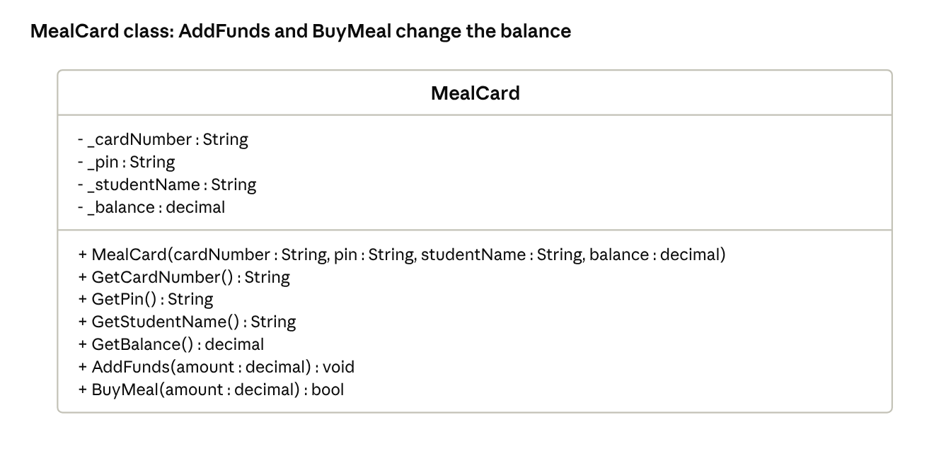
UML · MealCard class
Requirements
- Create a MealCard class that matches the UML above.
- AddFunds() adds the amount to the balance.
- BuyMeal() subtracts the amount and returns true only if the balance is big enough. Otherwise the balance stays the same and it returns false.
- The program starts with 5 cards:
Card number | PIN | Student | Balance
1001 | 1111 | Ava Brooks | $20.00
1002 | 2222 | Liam Carter | $5.50
1003 | 3333 | Mia Evans | $12.25
1004 | 4444 | Noah Foster | $0.00
1005 | 5555 | Zoe Grant | $40.00
- Only one card can be signed in at a time. Keep it in a form field: MealCard currentCard = null;
- If no card is signed in, Add Funds and Buy Meal display Please sign in first.
Form methods (in the form, called from button clicks)
- SignIn() accepts a card number and PIN as strings. If valid, signs the card in and displays Welcome, Ava Brooks and the balance. If invalid, signs out any current card and displays Invalid card number or PIN.
- SignOut() sets currentCard back to null and clears the display.
- AddMoney() accepts an amount as a decimal, calls AddFunds(), and displays the new balance.
- PayForMeal() accepts an amount as a decimal, calls BuyMeal(), and displays the new balance or Not enough money on card.

Demo4 MovieFinder (pairs with Lab4)
A searchable movie list for a movie night club.
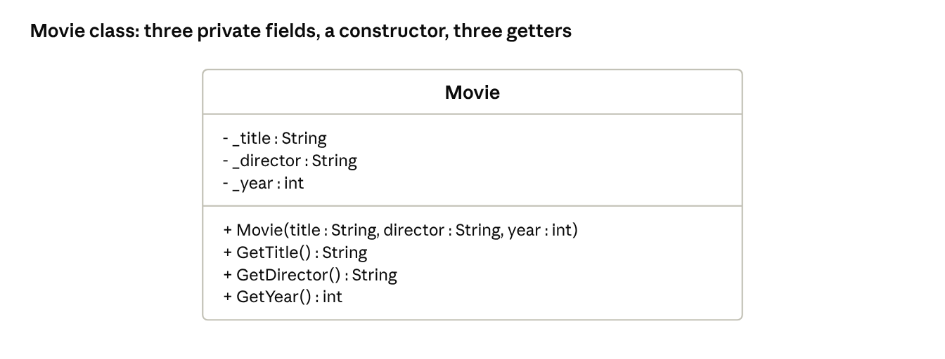
UML · Movie class
Requirements
- Create a Movie class that matches the UML above.
- Store these 5 movies in an array of Movie objects:
Title | Director | Year
Toy Story | John Lasseter | 1995
Jurassic Park | Steven Spielberg | 1993
Back to the Future | Robert Zemeckis | 1985
Finding Nemo | Andrew Stanton | 2003
Star Wars | George Lucas | 1977
- The user can search by title or director using one text box. The search is case-insensitive and matches part of a name (jurassic finds Jurassic Park; lucas finds Star Wars).
- If found, display the title, director and year. If not found, display Movie Not Found in each spot.
Form methods (in the form, not the Movie class, called on the button click)
- FindMovie() takes the search text and returns the index of the first matching movie, or -1 if none match.
- ShowMovie() takes an index. If it is valid, displays that movie's information. If it is -1, displays Movie Not Found.

Demo5 CarRental (pairs with Lab5)
A Windows Forms app that estimates the cost of a car rental. Note the UML uses properties instead of Get/Set methods.
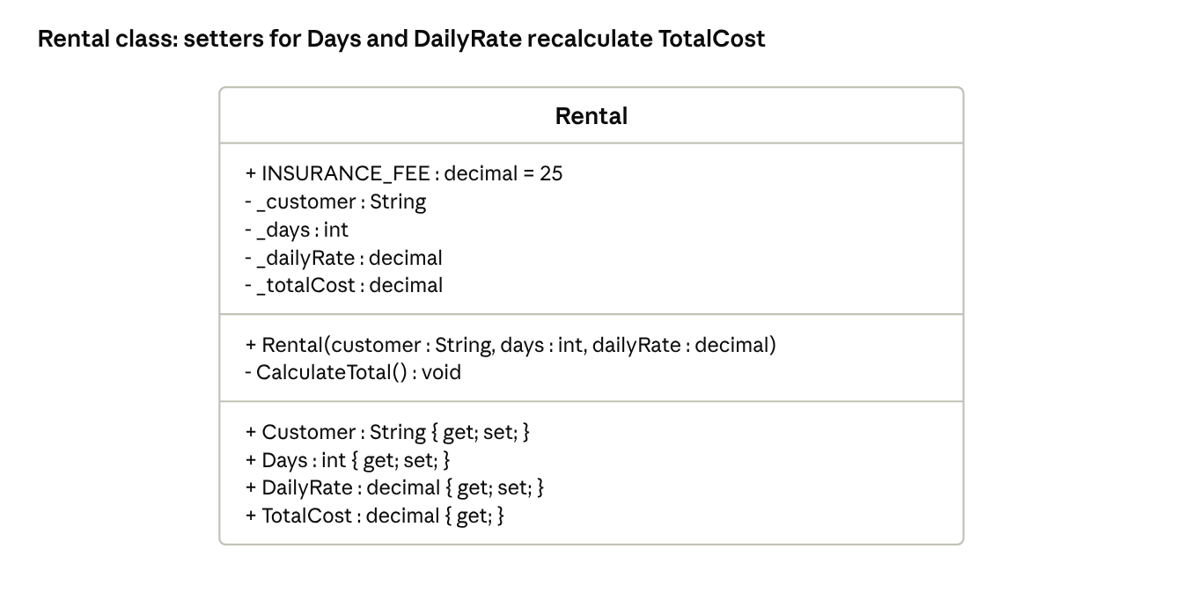
UML · Rental class
Requirements
- Create a Rental class that matches the UML above.
- Total cost = days × daily rate + a $25 insurance fee (INSURANCE_FEE). Example: 3 days × $40 + $25 = $145.
- CalculateTotal() is private and updates _totalCost. It is called by:
  - the constructor
  - the Days setter
  - the DailyRate setter
- TotalCost has a getter only, so the form cannot change it directly.
Each time the user clicks Calculate:
- If a Rental object has not been created, create one.
- If a Rental object already exists, update its properties.
- Display the customer, days, daily rate, insurance fee and total cost.

Demo6 PaintEstimate (pairs with Lab6)
A Windows Forms app that estimates how much paint each wall needs. One quart covers 100 square feet, plus one more quart for any partial 100.
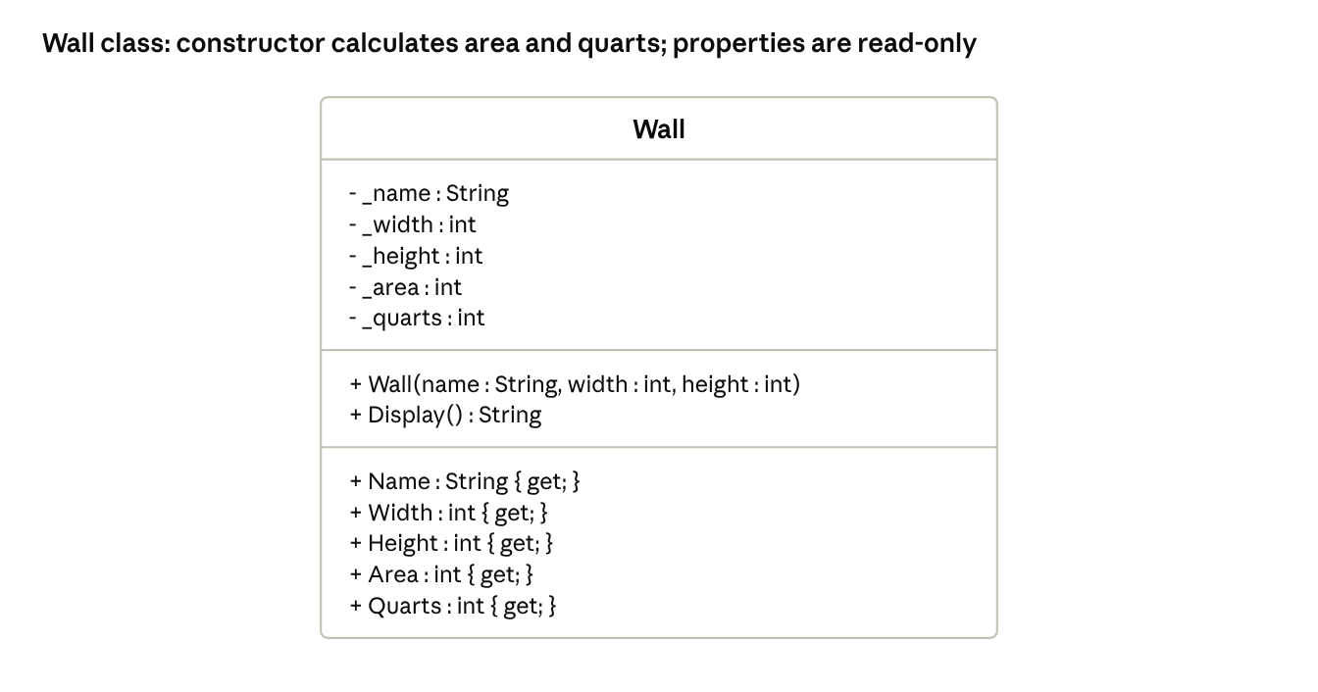
UML · Wall class
Requirements
- Create a Wall class that matches the UML above.
- The constructor saves the name, width and height, then calculates _area (width × height) and _quarts.
- Examples: 10×10 = 100 sq ft → 1 quart; 12×9 = 108 sq ft → 2 quarts.
- All five properties are read-only (get only).
- Display() returns: "{name} ({width}x{height}) needs {quarts} quarts", for example Kitchen (12x9) needs 2 quarts.
- The user can enter up to 20 walls. After 20, display Maximum of 20 walls.
Each time the user clicks Add:
- Create a new Wall object.
- Add it to an array of Wall objects.
- Show its Display() text in the output list.
- Clear the text boxes and set focus to the name box.

